Article Beyond the Brain 2018 for the Galileo Commission Site
About the Continuity of Consciousness
A concept based on scientific studies on Near-Death Experience
Introduction.
Ladies and gentlemen, I am very pleased that I get the opportunity to talk here today in the Beyond the Brain Conference 2018, as organised by the Scientific and Medical Network, about the science ánd mystery of the mind-brain relationship, based on recent scientific research on near-death experiences in survivors of cardiac arrest. A near-death experience (NDE), or an experience of enhanced consciousness during a period of apparent coma, still gives rise to many unbelieving and critical questions, especially by physicians and neuroscientists. Because, how can it scientifically be explained that people can have clear memories from a period of obvious unconsciousness? Or how is it possible that permanent life changes occur after a cardiac arrest of only two minutes? As long as one not has experienced an NDE himself it seems impossible to really understand the impact and the life changing after-effects of this overwhelming conscious experience. The existing worldview has radically changed. Quote: ‘You can be physically dead but your mind lives on. Only one thing matters: your attitude toward other people. I accept life as it is, and I am no longer afraid of death’. I will not only talk about changes in consciousness during and after an NDE, but above all I want to discuss my ideas about the possible relationship between consciousness and the brain. Important questions for me are: How is consciousness related to the integrity of brain function? Is it possible to gain insight in this relationship? Is there a biological basis of consciousness anyway? And is it possible to speak of a beginning of our consciousness and will our consciousness ever end? I realize that my approach will be new or unexpected for most neuroscientists, and that my conclusions will not always be in conformity with the currently widely accepted materialistic paradigm in western science.
I also realize that many aspects of consciousness, including the mind-brain relationship, are still a great mystery, because as the well-known philosopher David Chalmers has said: ‘Consciousness, the subjective experience of an Inner self, poses one of the greatest challenges to science. Even a detailed knowledge of the brain’s workings and neural correlates of consciousness may fail to explain how or why human beings have self-aware minds’. The question is: How can scientific research on NDE help us to understand more about the mystery of the mind-brain relationship? By asking this and other questions about consciousness my interest started in NDE research. In 1969, during my rotating internship, a patient was successfully resuscitated in the coronary care unit by electrical defibrillation. We mostly do not realize anymore that about 50 years ago all patients with cardiac arrest died because modern resuscitation techniques like defibrillation and external chest compression were not yet available. So before those years nobody survived a cardiac arrest. But this patient regained consciousness after a period of unconsciousness of about 4 minutes, and we as resuscitation team were of course very happy, but the patient seemed to be very, very disappointed. He told me about going through a tunnel, seeing a light and also beautiful colours and hearing music. I have never forgotten this event, but I did not do anything with it.
And in that time I did not know that in human history the same experiences have been told, in many cultures, in many religions and in all times, as shown in this painting from 1480 by the Dutch painter Hieronymus Bosch, showing deceased people escorted through a tunnel to the light. 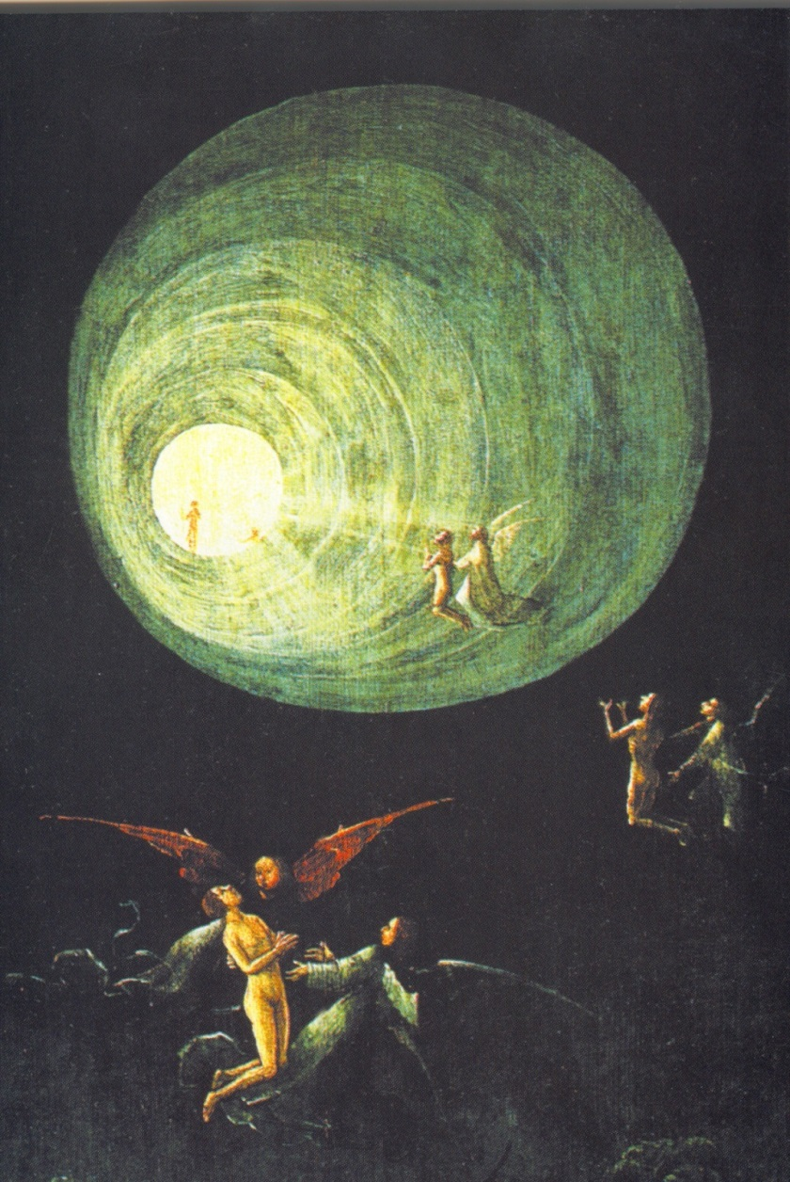
Only years later, in 1975, Raymond Moody first described the so-called “near-death experiences”, but only in 1986 I read about these experiences in the book by George Ritchie entitled “Return from Tomorrow,” which relates what he experienced during a period of clinical death of 9-minutes duration in 1943 during his medical study. After reading this book I started to interview my patients who had survived a cardiac arrest. And to my great surprise, within two years 12 patients out of 50 survivors of cardiac arrest in the past told me about their NDE. So for me it all started with scientific curiosity, because according to our current medical concepts, it is not possible to experience consciousness during a cardiac arrest, when circulation and breathing have ceased! I grew up in an academic environment in which I had been taught that it was obvious that consciousness was the product of a functioning brain. And up until that point, I had always accepted this as indisputably true. But now the phenomenon of near-death experience raised a number of fundamental questions: How and why does an NDE occur? How does the content of an NDE come about? Why does a person’s life change so radically after an NDE? I was unable to accept most of the answers to these questions, because they seemed incomplete, incorrect or unfounded.

What is a Near-Death Experience (NDE)?
Some people who have survived a life-threatening crisis report an extraordinary conscious experience. An NDE can be defined as the reported memory of a range of impressions during a special state of consciousness, including a number of ‘universal’ elements such as an out-of-body experience, pleasant feelings, seeing a tunnel, a light, deceased relatives, a life review, or the conscious return into the body. Many circumstances are described during which NDE are reported, such as cardiac arrest (clinical death), shock after loss of blood (complicated childbirth), coma following traumatic brain injury or stroke, near-drowning (children!) or asphyxia, but also NDE-like experiences are reported in serious diseases not immediately life-threatening, during severe depression, during isolation or meditation, or without any obvious reason. NDE-like experiences can also occur during the terminal phase of illness, and are called deathbed visions or end-of-life experiences. So apparently you don’t always need a non-functioning brain to report an NDE. The NDE is transformational, always causing profound changes of life-insight, the loss of fear of death, and enhanced intuitive sensitivity. This is why these kind of experiences are also called spiritual transformative experiences (STE).
Near-death experiences occur with increasing frequency because of improved survival rates resulting from modern techniques of resuscitation and from better treatment for patients with cerebral trauma. The content of an NDE and the effects on patients seem similar worldwide, across all cultures and all times. However, the subjective nature and absence of a frame of reference for this experience lead to individual, cultural, and religious factors determining the vocabulary used to describe and interpret this experience: children and adults, Christians and atheists, Muslims and Buddhists, they all use different words from their own religion, culture and tradition. According to a recent at random poll in Germany and the USA about 4% of the total population in the western world should have experienced an NDE. So about 2,5 million people in the UK, more than 10 million people in the USA, and about 20 million people in Europe must have had a NDE! Now why do we physicians hardly ever hear a patient tell about his NDE? Patients are so reluctant to share their experience with others by all the negative responses they get. Patients must feel that you trust them, that you can listen without any comment or prejudice. But for most physicians the NDE is still an incomprehensible and unknown phenomenon. Once a conference was held about NDE in a university hospital, with more than 300 persons in attendance. At the end of the conference, after several lectures about NDE, a man stood up, and said: “I am a cardiologist for more than 25 years, and I have never heard such absurd stories. This is total nonsense. I don’t believe one word of it”. Then another man got up in the audience and said: “I am one of your patients. I have had an NDE during cardiac arrest, and you would be the last one I would ever tell”.
The Dutch study on NDE
Until recently there was no prospective and scientifically designed study to explain the cause and content of an NDE, all studies had been retrospective and very selective with respect to patients. Based on these incomplete retrospective studies some believed the experience could be caused by physiological changes in the brain as a result of lack of oxygen (cerebral anoxia), other theories encompass a psychological reaction to approaching death, hallucinations, dreams, side effect of drugs, or just false memories.
So, in 1988 we started a prospective study of 344 consecutive survivors of cardiac arrest in ten Dutch hospitals with the aim to investigate the frequency, the cause and the content of an NDE. Our study was published in The Lancet in December 2001. We wanted to know if there could be a physiological, pharmacological, psychological or demographic explanation why people experience enhanced consciousness during a period of cardiac arrest. We did a short standardised interview with sufficiently recovered patients within a few days of resuscitation, and asked whether they could remember the period of unconsciousness, and what they recalled. We additionally performed a longitudinal study.
We studied patients who survived cardiac arrest, because this is a well-described life threatening medical situation, which is also called clinical death. The definition of clinical death was used for the period of unconsciousness caused by lack of oxygen in the brain due to the arrest of circulation and breathing that happens during cardiac arrest in patients with an acute myocardial infarction. These patients will ultimately die from irreversible damage to the brain if cardio-pulmonary resuscitation (CPR) is not initiated within 5 to 10 minutes. It is the closest model of the process of dying.
We found that 282 patients (82%) had no recollection of the period of cardiac arrest, of their period of unconsciousness. However, 62 patients (18%) reported some recollection of the time of clinical death. Of these patients 41 patients (12%) had a core experience with a score of 6 or higher, and 6% had a superficial NDE. And all well-known elements were reported, like awareness of being dead (50%), positive emotions (56%), an out-of-body experience (24%), moving through a tunnel (31%), communication with “the light” (23%), an observation of colours (23%) or of a celestial landscape (29%), a meeting with deceased relatives (32%), a life review (13%), and the experience of a border (8%). The more elements were reported, the deeper the experience was.
What might distinguish the small percentage of patients who report an NDE from those who do not? We found to our surprise that neither the duration of cardiac arrest ( 2 minutes or 8 minutes) nor the duration of unconsciousness (5 minutes or three weeks in coma), nor the need for intubation in complicated CPR, nor a short induced cardiac arrest in electrophysiological stimulation (EPS) had any influence on the frequency of NDE. So the degree or gravity of the lack of oxygen in the brain (anoxia) appeared to be irrelevant. So a physiological explanation for NDE like anoxia could be excluded. Neither could we find any relationship between the frequency of NDE and administered drugs, fear of death before the arrest, nor foreknowledge of NDE, gender, religion (Christian, Muslim, atheist) or education.
Longitudinal study
We additionally performed a longitudinal study with taped interviews 2 and 8 years following the cardiac arrest of all late survivors with NDE, along with a matched control group of survivors of cardiac arrest who did not report an NDE. This study was designed to assess whether the loss of fear of death, the transformation in attitude toward life and the enhanced intuitive sensitivity is the result of having an NDE or just the result of the cardiac arrest itself. This had never been studied before in a prospective design. The NDE turned out to be a life changing experience, because only patients with an NDE did show this aforementioned typical transformation. In particular, they were less afraid of death and had a stronger belief in an afterlife. We saw in them a greater interest in spirituality and questions about the purpose of life, as well as a greater acceptance of and love for oneself in combination with a feeling of oneness with others, and with nature. The conversations we had in our longitudinal study revealed that people, often to their own amazement and confusion, had acquired enhanced intuitive feelings after an NDE. Or, as many of them put it, they had acquired ‘paranormal gifts.’ This enhanced intuition is based on interconnectedness with the consciousness of others, and is independent of time (inner knowing of future events or having prognostic ‘dreams’) and independent of distance (the sense of knowing about an incoming phone call, and of pain, illness or upcoming death of people, which usually proves to be accurate). The sudden occurrence of this enhanced intuition can be quite problematic, as people suddenly have a very acute sense of others, which can be extremely intimidating. As someone told me: ‘I couldn’t even talk about it, or I would have been committed to an institution.’ Finally, it is quite remarkable and a surprising and unexpected finding to see a cardiac arrest lasting just a few minutes give rise to such a lifelong process of transformation. However, the integration and acceptance of an NDE is a process that may take many years because of its far-reaching impact on people’s pre-NDE understanding of life and value system. Despite the mostly positive experience the NDE is also a traumatic event, because there is hardly any acceptance by doctors, nurses, family and partner (with a divorce rate of more than 70%), which makes the process of acceptance and integration very difficult, and this process will take many, many years, with strong feelings of depression, homesickness and loneliness, but the longer interval between NDE and interview, the more positive changes are usually reported.
Other prospective studies on NDE.
In four prospective studies with identical study design, our Dutch study (the only study with statistical analysis), one study from the USA and two studies from the UK, about the same percentage of NDE was found in a total of 562 patients who survived cardiac arrest. And all authors conclude that no one physiological or psychological model by itself could explain all the common features of NDE. Bruce Greyson from the American study writes in his comment that the paradoxical occurrence of heightened, lucid awareness and logical thought processes during a period of impaired cerebral perfusion raises particular perplexing questions for our current understanding of consciousness and its relation to brain function. A clear sensorium and complex perceptual processes during a period of apparent clinical death challenge the concept that consciousness is localized exclusively in the brain. Sam Parnia and Peter Fenwick from the British study write that the data from several NDE studies suggest that the NDE arises during unconsciousness, and this is a surprising conclusion, because when the brain is so dysfunctional that the patient is deeply comatose, those cerebral structures, which underpin subjective experience and memory, must be severely impaired. Complex experiences such as are reported in the NDE should not arise, nor be retained in memory. Such patients would be expected to have no subjective experience at all. Penny Sartori from the other British study concludes that, according to mainstream science, it is quite impossible to find a scientific explanation for the NDE as long as we “believe” that consciousness is only a side effect of a functioning brain. The fact that people report lucid experiences in their consciousness when brain activity has ceased is, in her view, “difficult to reconcile with current medical opinion.”
With lack of evidence for any other theories for NDE, the concept thus far assumed but never scientifically proven, that consciousness and memories are produced by large groups of neurons and are localized in the brain should be discussed. How could a clear consciousness outside one’s body be experienced at the moment that the brain no longer functions during a period of clinical death, even with a flat EEG? Scientific study of NDE pushes us to the limits of our medical and neurophysiological ideas about the range of human consciousness and the mind-brain relation. An NDE might be considered as a changing state of consciousness, based on the theory of continuity of consciousness, in which memories, identity, and cognition, with emotion, function independently from the unconscious body, and retain the possibility of extra-sensory perception. Obviously, during NDE enhanced consciousness is experienced independently from the normal body-linked waking consciousness.
Some elements of an NDE
Before I discuss in greater detail some neurophysiological aspects of brain function during cardiac arrest, I would like to reconsider certain elements of the NDE.
First the Out-of-Body Experience. In this experience people have veridical perceptions from a position outside and above their lifeless body. NDE-ers have the feeling that they have apparently taken off their body like an old coat and to their surprise they appear to have retained their own identity with the possibility of perception, emotions, and a very clear consciousness. This out-of-body experience is scientifically important because doctors, nurses, and relatives can verify the reported perceptions, and they can also corroborate the precise moment the NDE with OBE occurred during the period of CPR. In two reviews with a total of more than 200 corroborated reports of potentially verifiable out-of-body perceptions it was found that about 98 percent of the reported OBE’s were completely accurate: through verification it was proven that all reported perceptions during coma, cardiac arrest or general anaesthesia were about details that really had happened. Based on these veridical aspects an OBE can, by definition, not be a hallucination, because this means experiencing a perception that has no basis in “reality”, like in psychosis, neither it can be a delusion, which is an incorrect assessment of a correct perception, nor an illusion, which means a misleading image.
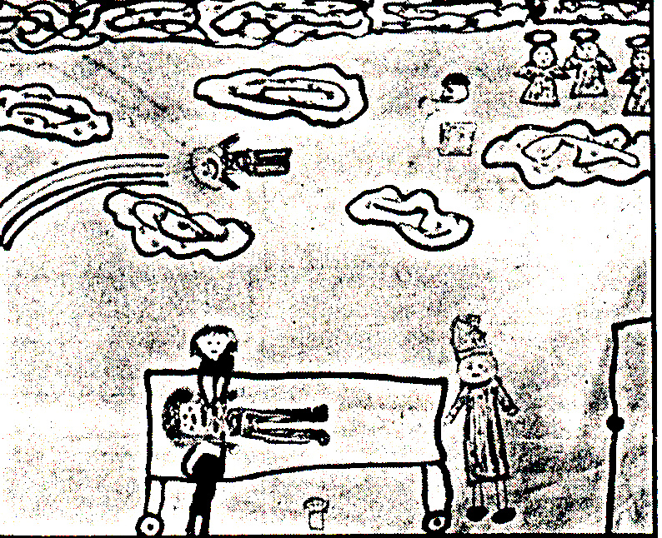
A real OBE is clearly shown in this drawing of a 6-year-old girl, who nearly drowned and was resuscitated in the hospital. In this drawing you see a happy and smiling girl watching her resuscitation with many correct details from above, like chest compression by two nurses. And this is the report of a nurse of a Coronary Care Unit: “During night shift an ambulance brings in a 44-year old cyanotic, comatose man into the coronary care unit. He was found in coma about 30 minutes before in a meadow. When we go to intubate the patient, he turns out to have dentures in his mouth. I remove these upper dentures and put them onto the ‘crash cart.’ Only after about an hour and a half the patient has sufficient heart rhythm and blood pressure, but he is still ventilated and intubated, and he is still comatose. He is transferred to the intensive care unit to continue the necessary artificial respiration for one week. After more than a week in coma do I meet again with the patient, who is by now back on the cardiac ward. The moment he sees me he says: ‘O, yes, you, you know where my dentures are.’ I am very, very surprised. Then the patient elucidates: ‘Yes, you were there when I was brought into hospital and you took my dentures out of my mouth and put them onto that cart, it had all these bottles on it and there was this sliding drawer underneath, and there you put my teeth.’ I was especially amazed because I remembered this happening while the man was in deep coma and in the process of CPR. It appeared that the man had seen himself lying in bed, that he had perceived from above how nurses and doctors had been busy with the CPR. He was also able to describe correctly and in detail the small room in which he had been resuscitated (where he was admitted in coma, and had left in coma), as well as the appearance of those present like myself.
The Holographic Life Review. During this life review the subject feels the presence and renewed experience of not only every act but also every thought from one’s past life, and one realizes that all of it is an energy field which influences oneself as well as others. All that has been done and thought seems to be significant and stored. Because one is connected with the memories, emotions and consciousness of another person, you experience the consequences of your own thoughts, words and actions to that other person at the very moment in the past that they occurred (interconnectedness). Patients survey their whole life in one glance; time and space do not seem to exist during such an experience (nonlocality). Quote: “All of my life up till the present seemed to be placed before me in a kind of panoramic, three-dimensional review, and each event seemed to be accompanied by a consciousness of good or evil or with an insight into cause or effect”. “Not only did I perceive everything from my own viewpoint, but I also knew the thoughts of everyone involved in the event, as if I had their thoughts within me. This meant that I perceived not only what I had done or thought, but even in what way it had influenced others, as if I saw things with all-seeing eyes. And so even your thoughts are apparently not wiped out. And all the time during the review the importance of love was emphasised. Looking back, I cannot say how long this life review and life insight lasted, it may have been long, for every subject came up, but at the same time it seemed just a fraction of a second, because I perceived it all at the same moment. Time and distance seemed not to exist. I was in all places at the same time, and sometimes my attention was drawn to something, and then I would be present there.”
Contact with the consciousness of deceased relatives (interconnectedness). Quote: “During my cardiac arrest I had a extensive experience (…) and later I saw, apart from my deceased grandmother, a man who had looked at me lovingly, but whom I did not know. More than 10 years later, at my mother’s deathbed, she confessed to me that I had been born out of an extramarital relationship, my father being a Jewish man who had been deported and killed during the second World War, and my mother showed me his picture. The unknown man that I had seen more than 10 years before during my NDE turned out to be my biological father.”
Conscious return in the body. Some patients can describe how they returned into their body, mostly through the top of the head, after they had come to understand that “it wasn’t their time yet” or that “they still had a task to fulfil.” The conscious return into the body is experienced as something very oppressive. They regain consciousness in their body and realize that they are “locked up” in their damaged body, meaning again all the pain and restriction of their disease. Quote: “When I came to in my body it was dreadful, so dreadful. . The experience had been so beautiful that I didn’t want to come back. I had wanted to stay there . . and yet I came back. From that moment it was a real struggle to live my life inside my body, with all the limitations I experienced at the time. . But later I realized that this experience was in fact a blessing, for now I know that the mind and body are separate and that there’s life after death.”
About all people who have experienced an NDE lose their fear of death. Quote: “It is outside my domain to discuss something that can only be proven by death. For me, however, this blessing experience was decisive in convincing me that consciousness lives on beyond the grave, and I know now for sure that body and mind are separated. Death was not death, but another form of life.”
Conclusions
So we have to come to the surprising conclusion that in our study during cardiac arrest all these reported elements of an NDE were experienced during a transient functional loss of all functions of the cortex and of the brainstem, with a flat line EEG. But how do we know that the EEG, the registration of the electrical activity of the cortex, is flat in those patients with cardiac arrest, and how can we study this? Through many studies with induced cardiac arrest, in both humans [like in threshold testing of ICD’s] and in animal models, cerebral function has been shown to be severely compromised during cardiac arrest, with complete cessation of cerebral flow, causing the clinical findings of the sudden loss of consciousness, the loss of breathing (apnoea), the loss of all body reflexes (cortex), but also the loss of all brainstem reflexes like the gag reflex, the corneal reflex, and fixed and dilated pupils. The electrical activity in the cerebral cortex (but also in the deeper structures of the brain in animals) has been shown to be absent after 10-20 seconds (a flat-line EEG). In an acute myocardial infarction the duration of cardiac arrest is always longer than 20 seconds. So all 562 survivors of cardiac arrest in the 4 prospective studies must have had a flat EEG.
Flat-line EEG during cardiac arrest
It is extremely rare that a simultaneous registration of the electrical activity of the heart (ECG) and of the cortex of the brain (EEG) during cardiac arrest could be monitored. A patient was referred because of sudden periods of unconsciousness. In the first three strips (A,B,C) (in a total registration of 60 seconds, each strip is 10 seconds) a spontaneous cardiac arrest (asystole) with loss of consciousness occurred (B). One can see that due to the lack of oxygen in the brain (anoxia) the EEG starts to change after about 8 seconds (C), and after 18 seconds in the second three strips (D,E,F) the registration shows that the EEG has become flat-line after 18 seconds (D). About 30 seconds after the onset of cardiac arrest a short period of ventricular tachycardia (VT) arises during 4 seconds (E), after which normal heart rhythm gradually recovers, and the EEG starts to normalize slowly some seconds later (F).
The patient received a pacemaker, after which he remained complaint-free.

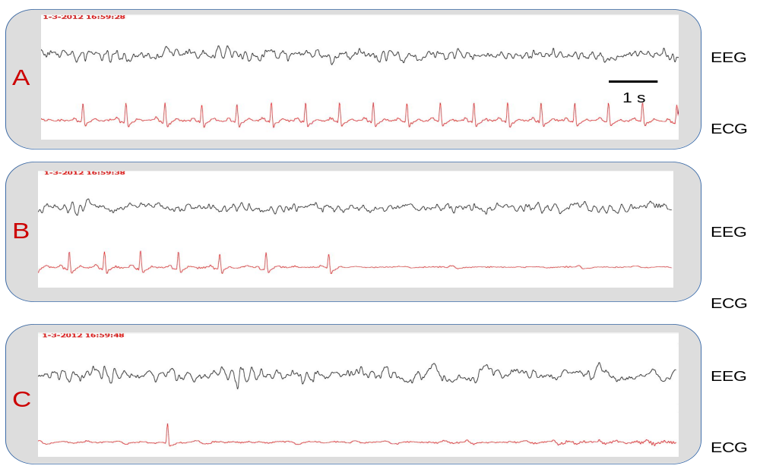

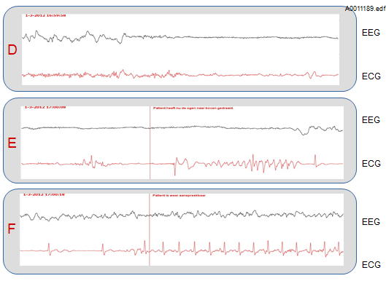

The conclusion that conscious experiences may occur during a flat-line EEG is often called impossible and unscientific. The quite often proposed objection that a flat-line EEG does not rule out any brain activity, because it is mainly a registration of electrical activity of the cerebral cortex, misses the mark. The issue is not whether there is any brain activity of any kind whatsoever, but whether there is measurable brain activity of the specific form regarded by contemporary neuroscience as the necessary condition of conscious experience, with visible activities in many neural centres, the so-called global neural workspace. And it has been proven that there is no such specific brain activity at all during cardiac arrest.
Summary.
For me it was indeed a scientific challenge to discuss new hypotheses that could explain the possibility to have clear and enhanced consciousness during a transient period of a non-functional brain, with memories, with Self-identity, with cognition, with emotion, with the possibility of perception out and above the lifeless body, to explain the reported interconnectedness with the consciousness of other persons and of deceased relatives, to explain the possibility to experience instantaneously and simultaneously (non-locality) a review and a preview of someone’s life in a dimension without our conventional body-linked concept of time and space, where all past, present and future events exist, and even to explain the experience of the conscious return into the body.
But most scientists still don’t believe in the possibility to experience an enhanced consciousness during a period of a non-functioning brain, because they cling to their own materialist dogma, and so they try to debunk everything I have said and written by simply stating that according to their current dogma it is obvious that an NDE must be produced by the brain. I would like to quote here Robert Oppenheimer, the famous American theoretical physicist, who has said: ’There is no place for dogma in science. The scientist is free, and must be free to ask any question, to doubt any assertion, to seek for evidence, to correct any errors’. Debunkers only change their mind as soon as they have experienced an NDE themselves, like Eben Alexander and many other physicians. So my advice to these debunkers is: try this small and dangerous footpath, and find out yourself.


My book ‘Endless Consciousness’ was published in 2007 in the Netherlands, and was translated into the English language as, ’Consciousness beyond Life’. It was a worldwide bestseller with more than 250.000 copies sold. In my book I have written that, based on prospective studies on NDE, based on recent findings in neurophysiological research, and in analogy with concepts from quantum physics, our consciousness cannot be localised in a certain time nor space.
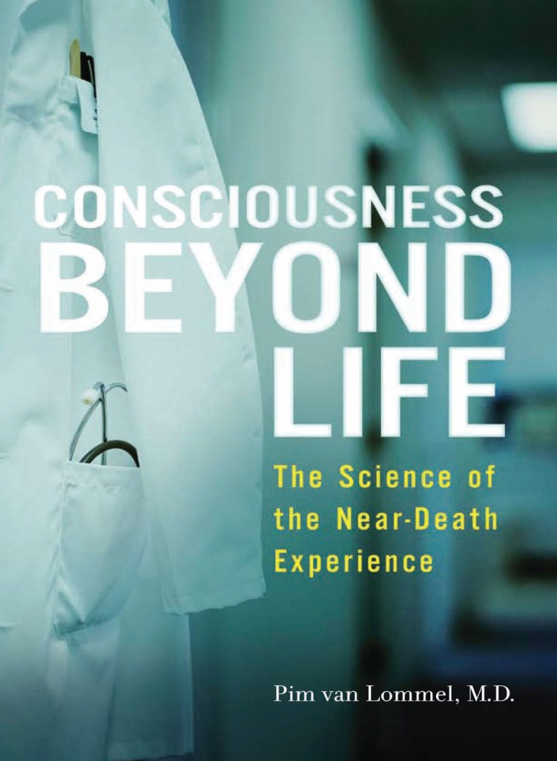
This is called nonlocal consciousness, because almost all of the reported aspects of consciousness during cardiac arrest seem to be quantum-like phenomena, like non-local interconnectedness, beyond time and space. In this concept our endless or nonlocal consciousness with declarative memories finds its origin in, and is stored in a nonlocal realm as wave-fields of information, and the brain only serves as a relay station for parts of these wave-fields of consciousness to be received into or as our waking consciousness. The function of the brain should so be compared with a transceiver, a transmitter/receiver, or interface, exactly like the function of a computer. Different neuronal networks function as interface for different aspects of our consciousness, and the function of neuronal networks should be regarded as receivers and conveyors, not as retainers of consciousness and memories. In this concept, nonlocal consciousness is not rooted in the measurable domain of physics, our manifest world. However, the physical aspect of consciousness, which originates from the wave aspect of our consciousness through collapse of the wave function (“objective reduction”) can be measured by means of neuro-imaging techniques like EEG, fMRI, and PET-scan. With this concept of nonlocal consciousness all reported elements of an NDE during cardiac arrest could be explained. In trying to understand this concept of interaction between nonlocal consciousness and the material body, it seems appropriate to compare it with modern worldwide communication. There is a continuous exchange of objective information by means of electromagnetic fields for radio, TV, mobile telephone, or laptop computer. At this very moment we are invaded by hundreds of thousands of telephone calls, and hundreds of radio and TV programmes, but we become only aware of these electromagnetic informative fields at the moment we use our mobile telephone or by switching on our radio, TV or laptop. What we receive is neither inside the instrument, nor in the components, but thanks to the receiver, the information from the electromagnetic fields (‘the cloud’) becomes observable to our senses and hence perception occurs in our consciousness. Internet with more than a billion websites can be received at about the same moment in the USA, in Europe and in Australia, and is obviously not located inside our laptop nor is it produced by it. Information from internet is always and everywhere available because it is stored in the cloud. This concept can be compared with nonlocal consciousness.
Other experiences of nonlocal consciousness.
A NDE, or an experience of an enhanced or nonlocal consciousness during a life-threatening situation like cardiac arrest or coma, and also during general anaesthesia, makes it extremely unlikely that consciousness could be a product of the function of the brain. Based on these experiences it seems inevitable to suggest that there will be a continuity of consciousness after death. But also experiences of an enhanced consciousness just before, during or after death support this conclusion.
1.Deathbedvisions, end-of-life experiences, or ELE: During the terminal phase of illness patients sometimes report encounters with deceased loved ones who welcome them, or the sight of a beautiful, unearthly environment and a bright light, a sense of unconditional love, or sometimes experiences only comprised of vague, intuitive images and an inner sense that the moment of transition is near. Like an NDE, such an end-of-life experience takes away the fear of death. Unfortunately many accounts of ELE’s are either not recognized as such or are interpreted as hallucinations, terminal confusion, or as the side effects of medication. It is difficult to find any specific brain mechanism that would underpin these spiritual end-of-life experiences.
2.Terminal lucidity. This is the unexpected return of mental clarity and memory shortly before death in patients suffering from severe neurologic disorders, like the end stage of Alzheimer disease. These patients suddenly become lucid again, recognise family members and children again, call them by name, thank them, and die. Terminal lucidity cannot be easily explained by normal neurologic processes, because it has been reported by patients who have severe Alzheimer disease for many years, or are in coma for days, and in these patients brain function must be severely impaired.
3.A shared-death experience can be reported by healthy people who are present at the bedside of a dying relative, and who share the death experience of this close relative at the moment of their death. They occasionally see a very special light in the room or around the bed of the dying person, with primary qualities of bliss, compassion and unconditional love. But sometimes they also join the ‘death experience’ of the person who just died. They may experience a tunnel, the Light, the feeling of love, and even sometimes meet deceased relatives or the life review of the person who just died. But suddenly they are back in their body again, at the bedside of the person who died just some minutes before.
4. Spiritual experiences of contact with the consciousness of a beloved person who is dying somewhere else are called ‘peri-mortal’ experiences. Sometimes a vision or a strong sense of the dying person from a long distance is perceived, mostly during sleep in a very clear ‘so-called’ dream or on a sudden awakening from sleep. To understand these experiences we have to step outside the current materialist scientific framework.
5. A so-called post-mortal experience, after-death communication, or ADC, is the feeling or inner knowing to be in contact with the consciousness of a deceased loved one in the first days, weeks or months following his or her death. This contact can consist of sensing a presence, feeling touched, or even seeing the deceased person and is sometimes accompanied by communication, certain fragrances, or unexpected “chance” incidents that are intuitively linked with the dead person. These experiences mostly occur during sleep, and this is why they usually call it ‘just a dream’. People will share these experiences only when they feel a great deal of trust and know that they will not be at the receiving end of prejudices or negative comments (“It’s just wishful thinking”; “It’s your grief talking”). In our Western society it is still a taboo to talk about the sensation of being in contact with a deceased loved one, despite the fact that about 125 million people in Europe, and about 100 million people in the USA must have had an ADC. The fact that contact is possible with the consciousness of a deceased relative is usually very comforting and helpful in the period of mourning, and healthcare workers or family members should not call an ADC a hallucination. There is no scientific explanation for these ADC’s as long as we believe that consciousness is only a side effect of a functioning brain. Research on NDE, ELE and ADC may be of great help to change our ideas about death, because based on these experiences it seems now beyond reasonable doubt that there must be a continuity of consciousness after the death of our body.
Additional experiences of non-local consciousness are:
1. Nonlocal information exchange. The interconnectedness with these informative fields of nonlocal consciousness also explains enhanced intuition, like clairvoyance, clairaudience, prognostic dreams, premonitions, and visions. As I told before, following an NDE most people, often to their own amazement and confusion, may experience such an enhanced intuitive sensibility, which means having access to nonlocal information that is not received by our senses or by our body. Presumably the functional receiving capacity of the body is permanently enhanced following an NDE, which can be compared with a radio, receiving not only channel 1, your own personal consciousness, but at the same time channel 2, 3 and 4, the fields of consciousness of others. William James called this a lower personal ‘threshold of consciousness’.
And perhaps also cases of spontaneous reports of reincarnation can be understood by nonlocal information exchange.
2. Nonlocal entanglement seems also to be demonstrated in nonlocal perception (remote viewing), which is the ability of an individual to acquire perceptive information that should not be accessible because of shielding from space and time by our sensory organs. There haves been a lot of studies done like in the Stanford Research Institute, CIA programmes, Princeton Engineering Anomalies Research Laboratory (PEAR) and in The Alexandria Project.
3. Nonlocal perturbation is the effect of non-local consciousness on matter, like in nonlocal healing, or healing on a distance, where objective changes have been shown in fMRI studies with correlations between distant intentionality and brain function in recipients, even in a Faraday cage.
Nonlocal perturbation is also shown in neuroplasticity, where in EEG, fMRI and PET-scan studies functional and structural changes in the brain are demonstrated following changes in consciousness like in meditation, mindfulness training or in placebo-treatment in patients with severe depression, chronic pain, or Parkinson disease. It seems now clear: it is ‘Mind over Matter’.
NDE and its impact on science.
Since the publication of several prospective studies on NDE in survivors of cardiac arrest, with strikingly similar results and conclusions, the phenomenon of the NDE can no longer be scientifically ignored. It is an authentic experience which cannot be simply reduced to imagination, fear of death, hallucination, psychosis, the use of drugs, or oxygen deficiency, and people appear to be permanently changed by an NDE during a cardiac arrest of only some minutes duration. According to these studies, the current materialistic view of the relationship between the brain and consciousness held by most physicians, philosophers and psychologists is too restricted for a proper understanding of this phenomenon. Materialistic science starts principally from a reality that is only based on physical observable data. But we should be aware that, besides external and so-called objective perception and observation, there are also subjective, not observable and not demonstrable aspects like thoughts, feelings, inspiration and intuition. We can only measure the electrical, magnetic, chemical activities in the brain by EEG, MEG and PET-scan, and we can measure changes in blood flow in the brain by fMRI, but these are only neural correlates of consciousness. These measurements do not explain anything about the production nor about the content of consciousness. With our currently available scientific and objective techniques one is not able to even prove, measure, objectify nor falsify the content of the subjective experiences in our consciousness. Direct proof about how neurons or neuronal networks could possibly produce the subjective essence of our thoughts and feelings is totally missing. By making a scientific case for consciousness as a nonlocal and thus ubiquitous phenomenon, this view can contribute to new ideas about the relationship between consciousness and the brain.
By making a scientific case for nonlocal consciousness we must question a purely materialist paradigm in science, and it seems to be important for our scientific ideas about the mind-brain and mind-body relationship. It is also evident that it is important for our concepts of life and death because of the almost unavoidable conclusion that at the time of physical death consciousness will continue to be experienced in another dimension, in which all past, present and future is enclosed. Quote: “Death is only the end of our physical aspects”. I believe now that death, like birth, may be a mere passing from one state of consciousness into another. However, we should acknowledge that research on NDE cannot give us the irrefutable scientific proof of this conclusion, because people with an NDE did not quite die, but they all were very close to death, and without a functioning brain. But it has now indeed been scientifically proven that during NDE enhanced consciousness was experienced independently of a functioning brain. Without a body we still can have conscious experiences, we are still conscious beings. So we have a body and we are conscious. Recently someone with an NDE wrote me: ‘I can live without my body, but apparently my body cannot live without me’. The NDE seems to be a personal re-discovery of wisdom and insight that is ages and ages old, and has been well known in many cultures and in all times, but nowadays seem to be forgotten. I would like to quote Plato, who wrote more than 2000 years ago: ‘The temporary material body is the temporary carrier of our immortal soul. Time does not exist in the immaterial world’. So based on scientific research on NDE I cannot avoid the conclusion that endless consciousness has been and always will exist independently from the body. There is no beginning nor will there ever be an end to our consciousness. Our enhanced consciousness resides not in our brain and is not limited to our brain, because our consciousness is nonlocal, and our brain has a facilitating function, and not a producing function to experience consciousness.
Already more than a century ago psychologists William James and Frederic Myers studied extraordinary experiences in our consciousness. Both called into question the –still dominant– view that consciousness is a product of the brain, and even in 1898 William James wrote that the brain’s role in the experience of consciousness is not a productive, but a permissive or transmissive role; that is, it admits or transmits information. Myers’ and James’ made a major contribution to the study and description of special states of consciousness, such as mystical or religious experiences, unconscious aspects of man (‘subliminal consciousness’), hypnosis, trance, premonitions, and physical changes caused by suggestion. William James wrote about these experiences and concluded: To plead a ‘physiological’ causation of a religious state of mind is quite illogical and arbitrary. The total expression of human experience, as I view it objectively, invincibly urges me beyond the current narrow 'scientific' bounds’. In his view consciousness does not originate in this physical world, but already exists in another, transcendental sphere; access to aspects of consciousness depends on the personal ‘threshold of consciousness’, which for some people is lower than for others, and which allows them to experience various aspects of enhanced consciousness. And Frederic Myers wrote: ‘If consciousness be a mere epiphenomenon we shall of course expect that consciousness is exclusively linked with the functional disintegration of central nervous elements [..] Yet now and then we find a case where vivid consciousness has existed during a state of apparent coma [..] Until this new field has been more fully worked out we have no right to make any absolute assertion as to the concomitant cerebral processes on which consciousness depends.’ William James speaks of the continuity of consciousness and both his approach and his terminology are remarkably similar to my concept of non-local consciousness. In a posthumously published book also Myers wrote about the human personality surviving physical death, while James too was convinced that man’s consciousness lends him an aspect of immortality. They were both in contact with the famous French philosopher Henri Bergson, who once had written: ‘The more we become accustomed to this idea of a consciousness which overflows the organ we call the brain, then the more natural and probable we find the hypothesis that the soul survives the body’. For obvious reasons there was also one century ago a lot of criticism about their conclusions, so William James once should have added (quote): ‘First, you know, a new theory is attacked as absurd; then it is admitted to be true, but obvious and insignificant; finally it is seen to be so important that its adversaries claim that they themselves discovered it’.
Consciousness beyond the Brain
Today more and more cognitive scientists, neuroscientists, and philosophers come to the inevitable conclusion that it is extremely unlikely that consciousness could be a product of brain function, which confirms what the Australian neurophysiologist, philosopher and Nobel prize winner Sir John Eccles (1903-1997) has once stated: ‘The brain is the messenger to consciousness’. Interestingly, the English physicist, astronomer and mathematician Sir James Jeans (1877-1946) wrote already many, many years ago: ‘I incline to the idealistic theory that consciousness is fundamental, and that the material universe is derivative from consciousness, not consciousness from the material universe’. And even in 1931 the famous Nobel Prize winner and originator of quantum theory Max Planck has said: ‘I regard consciousness as fundamental. I regard matter as derivative from consciousness. We cannot get behind consciousness. Everything that we talk about, everything that we regard as existing, postulates consciousness’. This is again recently confirmed by Donald Hoffman, an American cognitive scientist, who has written: 'Conscious realism is a non-physicalist monism: Consciousness is ontologically fundamental. Consciousness is first; matter and fields depend on it for their very existence. ' And quantum physicist Jude Currivan has stated: ‘We, our consciousness, and all things in the universe, are non-locally connected with each other and with all other things in ways that are unfettered by the hitherto known limitations of space and time.”. Based on all the aforementioned research and conclusions I realize now that consciousness is fundamental, and that everything originates from consciousness.
Conclusions NDE –Research
In the past a lot has been written about life and death, and also about special states of enhanced, or nonlocal, consciousness. But surprisingly, many people nowadays still have never heard about NDE’s or ADC’s, and this is why they still ‘believe’ that death is the end of our existence and the end of our consciousness. People are afraid that with death everything comes to an end. As a young doctor this was also my idea about death. But based on the results and conclusions of recent NDE research my current view is now: ‘There are good reasons to assume that our consciousness does not always coincide with the functioning of our brain: enhanced consciousness can sometimes be experienced separately from the body’. Remarkably, in a recent representative social poll in Europe about 55 per cent of the population, more than 250 million people, believed in some kind of personal survival, and in the USA this percentage is even higher. These surprising high figures are in sharp contrast with the opinion of the majority of Western scientists, who systematically ignore and ridicule the possibility of personal survival after physical death. The current materialistic view on the mind-brain relationship is too restricted for a proper understanding of the Near-Death Experience. We need a new ‘post-materialist’ approach in science to accept these new concepts, but new ideas are usually ridiculed or neglected, as the physician Ian Stevenson, who published a lot about reincarnation, once stated: ‘It has been said that there is nothing so troublesome as a new idea and I think that is particularly true in science’. And I sincerely hope that quantum physicist Max Planck was wrong when he said in 1934: “A new scientific truth does not triumph by convincing its opponents and making them see the light, but rather because its opponents eventually die, and a new generation grows up that is familiar with it.” So we desperately need a real paradigm shift in science, we need to expend science as soon as possible to be able to include subjective experiences!
Regarding what we can learn from people who are willing to share their NDE or ADC with others, I would like to quote Dag Hammerskjöld: “Our ideas about death define how we live our life”. Because as long as we believe that death is the end of everything we are, we will give our energy toward the temporary and material aspects of our life. In our short-sightedness and sometimes wilful ignorance we forget to reflect on the future of our planet, where our children and our grandchildren will have to live, and survive. We forget about sustainability as we are now destroying and exhausting systematically our planet, just because we are living in a competitive and materialistic society. We should realize that the harm we cause to each other and to nature ultimately is harming ourselves, because we as humans are not only intensively interconnected (‘entangled’) with each other, but also with animals and plants living on our endangered earth. I hope that in the near future we will accept non-local concepts to understand how we are, and always will be, interconnected with each other, also after physical death, and that we have to change our personal consciousness, not only to change the way we live but also to change the way we want to respect people who are willing and able to share their NDE, ELE, or ADC with us. Theír lives changed in ways they were not prepared for, and they all tell us that they fundamentally changed their ideas about life and death, because (quote) ‘You can be physically dead but your mind lives on’. Another quote: ‘Death was not death, but another form of life’. Consciousness seems to be our essence, and once we leave our body, leave our physical world, we exist as pure consciousness, beyond time and space, and are we enfolded in pure, unconditional love. Obviously, this new insight helps us to better understand the idea of human consciousness beyond the brain. And as a woman with an NDE wrote to me: “When the power of love becomes stronger than our love of power, our world will change”. It will require a huge change in consciousness indeed. We should all feel the responsibility for this change. Thank you for your attention.

Pim van Lommel, cardiologist, NDE-researcher, author of ‘Consciousness beyond Life’.
Short Bio: Pim van Lommel, M.D., born in 1943, graduated in 1971 at the University of Utrecht, and finished his specialization in cardiology in 1976. He worked from 1977-2003 as a cardiologist in Hospital Rijnstate, a 800 beds Teaching Hospital in Arnhem, the Netherlands, and is now doing full-time research on the mind-brain relation. He published several articles on cardiology, but since he started his research on near-death experiences (NDE) in survivors of cardiac arrest in 1986 he is the author of over 20 articles (most of them in Dutch), one book and many chapters about NDE. In 2005 he was granted with the Dr. Bruce Greyson Research Award of the International Association of Near-Death Studies (IANDS). In 2006, the president of India rewarded him the Life Time Achievement Award at the World Congress on Clinical and Preventive Cardiology in New Dehli. His Dutch book ‘Endless Consciousness’ was nominated for the ‘Book of the Year 2008’ in the Netherlands. In 2010 he received the 2010 Book Award van de Scientific and Medical Network, and in 2017 he received the Elisabeth Kübler-Ross Award by the Dutch Society of Volunteers in Palliative and Terminal Care (VPTZ).
Book: In November 2007 his book ‘Endless Consciousness’ (Eindeloos Bewustzijn) was published in The Netherlands, which is a bestseller with more than 145.000 copies sold (24th edition). His book was published in Germany in 2009 (already the 10th edition), and it has been published in the English language by Harper Collins in 2010, entitled: Consciousness beyond Life. The science of the near-death Experience. In 2011 the Polish edition was published, the Spanish translation was published in March 2012, and in May 2012 his book was published in France. In December 2015 the book was also published in Latvia, and in January 2017 the book was published in Italy. In 2018 the book will be published in China and Hungary as well. By now more than 250.000 copies have been sold worldwide.
Website: www.consciousnessbeyondlife.com.
Articles: (see https://pimvanlommel.nl/en/pim-van-lommel/scientific-publications/ .
- Van Lommel P, Van Wees R, Meyers V, Elfferich I. Near-death experience in survivors of cardiac arrest: a prospective study in the Netherlands. The Lancet 2001; 358: 2039-2045. (more than 700 citations!)
- Van Lommel, P. About the Continuity of our Consciousness, Adv Exp Med Biol. 2004; 550: 115-132. [Brain Death and Disorders of Consciousness. Machado, C. and Shewmon, D.A., Eds. New York, Boston, Dordrecht, London, Moscow: Kluwer Academic/ Plenum Publishers]
- Van Lommel, P. Near-Death Experience, Consciousness and the Brain: A new concept about the continuity of our consciousness based on recent scientific research on near-death experience in survivors of cardiac arrest. World Futures, The Journal of General Evolution, 2006; 62: 134-151.
- Van Lommel, P. Near-death experiences: the experience of the self as real and not as an illusion. 2011; Ann. N.Y. Acad. Sci. 1234: 19-28.
- Van Lommel, P. Nonlocal Consciousness. A concept based on scientific research on near-death experiences during cardiac arrest. 2013; Journal of Consciousness Studies, 20, No. 1–2 : 7-48.

