BACK TO THE AETHER IN PHYSICS AND COSMOLOGY! by Dr. Adrian Klein, Ph.D.

ABSTRACT.
The concept of a universal medium pervading everything, the aether, has been long ago rejected by mainstream science as a speculative one, especially after the famous Michelson-Morley experiment that failed to confirm the reality of a luminiferous essence invoked for the propagation of E.M. waves. Nevertheless, the concept has been re-established as a serious, experimentally proven one, by the work of Nicola Tesla, the genial physicist widely recognized in modern academic circles. His achievements are quite unparalleled in experimental physics, and recently recalled to public attention by Serbian researcher Goran Marjanovic – whose papers have been published in various academic editorial outputs of high credibility.
In this paper, we draw a meaningful link between a couple of strongly coherent and mutually supportive conceptual tenets regarding the aether’s physics and cosmology – the one worked out by Nicola Tesla and reactualized in our memory by Dr. Goran Marjanovic, and the one that constitutes a pivotal background of the sub-quantum sentience tenets as worked out by Klein & Boyd in more than a decade of exploration done in these fields of uttermost scientific importance.
After reviewing some of G. Marjanovic’s well documented tenets inspired from Nicola Tesla’s genial findings, here we intend to add a few strongly supportive ones regarding the validity of some fundamental principles about the aether, from our own perspective (Klein & Boyd). Our argumentation in this paper is fully inspired from Dr. R. N. Boyd’s loudly applauded lecture at the Physics beyond relativity” conference, Prague 2019 (we uploaded this event in our “Conferences & Symposium” section to our platform.
To begin with, as Dr. Marjanovic correctly puts it, if modern science honestly challenges to achieve a really accurate description of reality, it has to accept often inconvenient hard facts whose explanation generally defies canonically perpetuated beliefs based on obsolete, often falsified premises (such as the intently “reduced” set of the Maxwell equations, which resulted in a catastrophic dimensional reduction, elimination of scalar waves and of extensible torsion fields that travel at c^10 transferring Information stored in their memory). We have to remember that Maxwell himself ascribed EM waves and scalar waves propagations to a super-fluid medium, describing both of them both as disturbances in the aether. Scalar waves are certainly involved in all formative processes by their Informational content, and propagate at superluminal velocities transcending space/time constraints.
Though modern taxonomy tries replacing original terms (aether) by new ones (superfluid quantum vacuum), terminology will never hide its real background that is well known to honest explorers of the basic features inherent in our Universe.
This medium for subtle energy dynamics with super-luminal velocity propagation is permanently interacting with classical energy and force fields via their Informational content. These interactions with a counter-entropic effect on their impact targets barely begin to be accepted by advanced theorists of Quantum physics (Energy Density Quantization Model) – EDQM), as a source of order and harmony in nature. As N. Tesla noticed, one of the reasons invoked by mainstream scientists to reject the existence of the aether has been complying to the Einsteinian tenet of velocity limit in nature, c. As soon as we are exploring reality in its hyperdimensional frame of reference, it gets obvious that relativistic constraints do not apply beyond their own 4D manifestation domain, thus superluminal velocity transfers, up to infinite velocity variants, are not only conceivable but provable, too. Tesla proved that EM wave propagation parameters correspond to volumetric fluctuations of aether, the fundamental background of wave dynamics, with a density accurately calculated by him to be 2×10^-26 g/cm^3.
The Tesla waves correspond in their corpuscular aspect to the G. Marjanovic’s “Teslion” – which basically may be compared (at their respective scales) to our (Klein & Boyd) infinitesimal sub-quantum unit.
G. Marjanovic (2014a) gives a detailed description of evidences based on accurate mathematical expressions, addressing quantum equivalence transforms inspired from the EDQM postulates, supplying the reader with a compelling diagram of these equivalences between the wave/corpuscular correspondences at all scales of magnitude, extending from 10^-14m to 10^14m, from the domain of cosmic rays to the nonlocal Information-controlled regime beyond the hyperdimensional equator, which marks the transition from quantum physics to sub-quantum dynamics (Fig. 1).
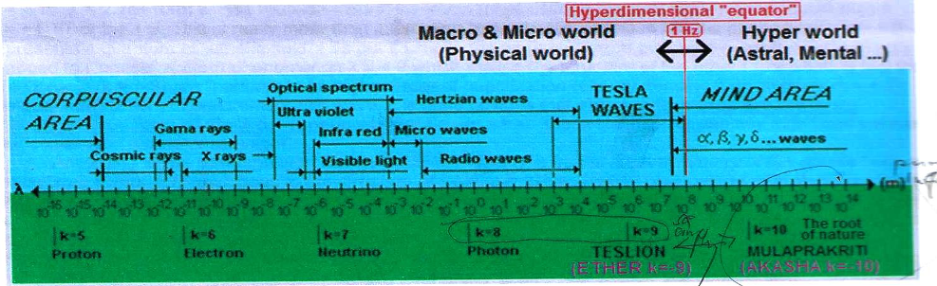
Fig. 1. Scale magnitude distributions from radiative corpuscular to non-local domains
Source: Marjanovic, G. (2014a). Akasha-forerunner of Ether – “Superfluid quantum vacuum”, p. 5.
The author extensively explains equivalences of various quantization levels and their inverted values in terms of established physical constants, reaching out into nonlocal regimes, where a “stable primary substance” is postulated as a forerunner of the aether (k=-10). Here we are obviously in the domain of sub-quantum, Information-controlled implicate orders of reality, the domain of enfolded causal agents of the 4D unfolded manifestation forms. Akasha is diagrammatically positioned in this domain, which confirms our own conceptual claims. Describing Akasha as an aether pro-element populated by infinitely small entities (k=+10), Tesla’s calculations lead to defining an elementary phenomenon, “Mulaprakrithi”, which may be viewed as a correspondent of our (Klein & Boyd) Buthatma, the infinitesimal unit of space, time and consciousness. This is the level where Information couples to space/time constructs, at the point described by Marjanovic as the “hyperdimensional equator”. Hyperdimensional geometry and resonances governing quality properties in the 4D “physical” world get understandable with this new approach to the sentient Universe.
G. Marjanovic also offers in his paper (2018) a clear quadrantic representation of Total Reality, contending both the tangible and the nonlocal domains, separated by the hyperdimensional equator, which corresponds to the 1HZ vibration value (the one of the beating human heart). In this diagram, subtle energy variants extend downwards to the Planck limit, where the junction to Information-controlled sub-quantum regime is accomplished (Fig. 2).
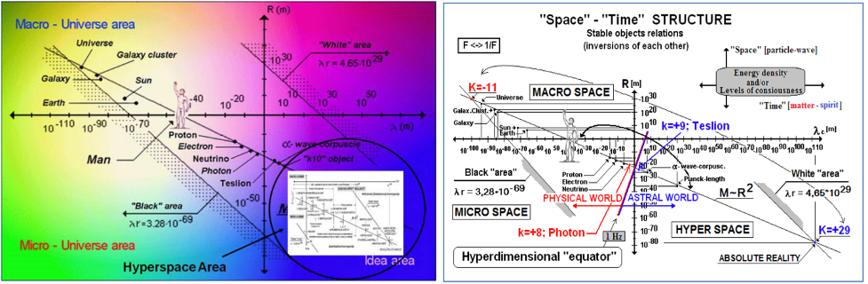
Fig. 2. Quadrantic representation of dimensional and hyperdimensional magnitude orders
Source: Marjanovic, G. (2018). Pyramids and Scalar Waves, p. 7.
The EDQM model allows for a more accurate understanding of the Information-controlled physical manifestations, by envisaging the coupling level of their physical and non-physical forms. Their “inverse-opposing mirror images” are a compelling key for exploring the non-physical dynamics through their projections into the physical, a unique extrapolation tool for researchers of the reality zones hidden from direct sensory detection modalities. Expressed in terms of quantization levels, emotional reactivity corresponds to k=9, while the rough material world to k=8. Interestingly enough, the Upanishadic cosmogony is perfectly coherent with the theosophic scheme, placing the “mental level” at the k=10 quantum position.
Marjanovic compellingly illustrates his tenets with minute details of construction detectable in the great pyramids of our planet suggesting a purposeful program used for creating a multi-dimensional resonator device (2014b) based on the Earth frequency of 11.78Hz.
Earth’s Shuman frequencies are obviously correlable to the EEG alpha brain waves. Thus, man is supplied with a double anchorage system, being conveniently placed between Earth’s fundamental frequency spectrum and the Information carrier systems originating in nonlocal domains, conveyed by pre-quantum mediators (subtle energies).
All creative processes in the physical regime are emphatically induced and controlled from the non-physical ones – as both the Tesla-inspired and our (Klein & Boyd) model strongly support.
Let’s try now completing the aforementioned very important insights of N. Tesla by a few ones inspired from a few most advanced cosmological claims (Klein & Boyd, 2008, Boyd, n.d., 2019).
To begin with, we consider subjective experience (senses, being, intuition and emotions) as a non-reductible fundamental prime, the core-stuff of the universal sentient Reality. Subjective experience is contended in the aether, but not quite identical to it because this ontological essence is also embedded in matter and energy (in order to manifest in our physical world in objectively quantifiable values).
In our concept, everything (the vacuum included) has memory – as compellingly proved by P. Gariaev’s experimental setup (laser correlation spectroscop) for exploring the „Phantom DNA”
Seen as an all-pervading essence (matter as well as energy structures embedded in it), aether may be roughly identified with pure informational memory. Hence, as everything has experiences and memory conveyed by aether, everything has consciousness of some kind, but also uniqueness and personality. The experiencing effect is conveyed to everything by way of motional aether flows. They are radiating from the Source, linking various end-points, thus unifying everything in terms of experiencing. This motional aether is the Quantum Information Field, which operates with any velocity values up to infinite velocity.
Regarding propagation mechanisms in the aether, based on novel solutions for the Maxwell equations, Dr. R. N. Boyd supports a new astrophysical consequence that describes a magneto-electric radiation traveling from infinity toward the source-point with a velocity of c^2. This is a `vacuum compensation` mechanism leading to a force balance in the vacuum, a net zero force over time. He states that superluminal conformal forces of this kind (based on superluminal solutions for the Maxwell equations related to Moebius transforms) exist, though at the stage of our current technology still not instrumentable. According to R. M. Kiehn, the non-linear moebius projective transformation fractional solution to the Maxwell equations allows for infinite propagation speeds of the E/M singularity.
A compelling representation of the universal aether’s partition into increasing density spectra may be found in Mishin’s diagram of „phases” that aether may display in its matter/energy manifestation modes (Fig. 3).
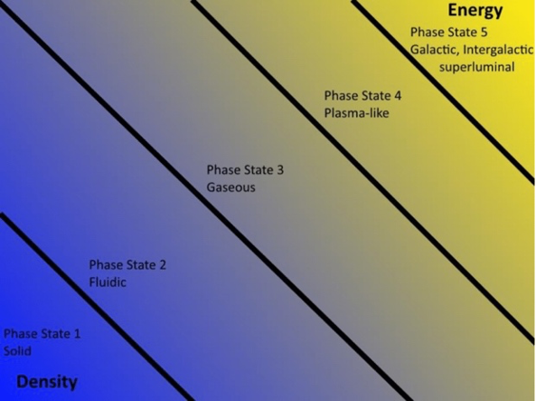
Fig. 3. Aether Phases (Mishin)
Source: Boyd, R. N. (2019). Continuous creation/dis-creation of matter and energy in an infinite volume, constantly equilibrating universe
According to the Mishin diagram, energy is the 5th phase state of the aether, the last one after the 4th (plasma-like), 3rd (gaseous), 2nd (fluidic) and 1st (solid) ones.
To avoid any misinterpretation, we remind the reader that Mishin’s 5 phase diagram of the “pre-matter” aether has its perfect correspondence in the “normal” matter, too.
Beyond this spectrum, the sub-quantum aether (manifested as Bhutatmas and vortex lines) is the way storage and transport of experience is accomplished. The sub-quantum Information field and its activity are the only accurate description of every kinds of known phenomena and implies superluminal velocity transfers. As Dr. Boyd points out in support of this tenant, “when an electric field at a given point is evaluated according to Lienard-Wiechert potential, the result is identical to the one which is obtained hypothesizing that the Coulomb field propagates with infinite velocity, carrying Information conveyed by sub-quantum infinitesimals”.
At a cosmological scale, aether-plasmoids are living at the center of every galaxy and produce expanding shells of aether convertible to matter, via periodic and stochastic quantized events, which are able to change the laws of physics locally – as each expanding shell of increased aether density passes through the local volume altering its fine structure constant. Hence quantized red-shift of galaxies (Fig. 4 & 5).
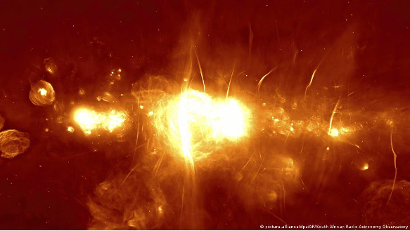
Fig. 4. Galactic aether-plasmoid expanding cores.
Close-up of Aether-Plasmoid Center of Milky Way
Source: Illustration – Square Kilometer Array, South Africa
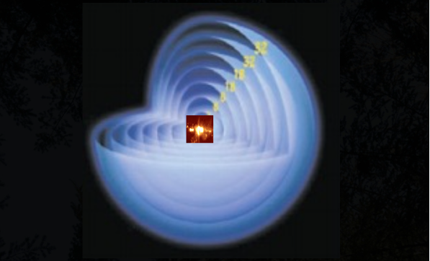
Fig. 5. Galactic aether-plasmoid expanding cores
The Aether-Plasmoid which lives at the Center of every Galaxy produces expanding shells of Aether-matter
Source: Boyd, R. N. (2019). Continuous creation/dis-creation of matter and energy in an infinite volume, constantly equilibrating universe
At the atomic level, a complex interplay between an atom’s constituents and aether flux variants works by dematerialization effects of atoms, thus leading to various shape dynamics, by dissociating into sub-quantum aether and vortex lines. This happens whenever a gamma-ray wavelength equals the size of the atom (10e – 12m). As vortex lines have finite strength (vorticity times area) but zero area – they tend to propagate at infinite velocity as long as the lines remain absolutely straight. They are infinite velocity sub-quantum infinitesimal particles originating in atomic dissociations by resonant gamma-rays (Fig. 6 & 7). These vortex lines are, in the sub-quantum concept, the primary cause of gravitation, too. In a similar process, resonant gamma-ray dissociation of atoms, as well as high dv/dt E discharges, cause the subatomic particles to revert to vortex lines and sub-quantum aether.
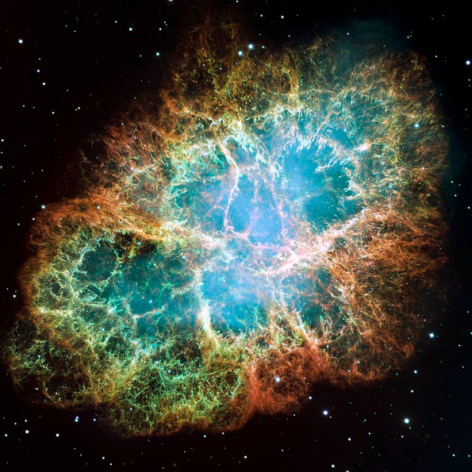
Fig. 6. Atomic interaction with gamma-rays
If Gamma Ray wavelenght = The Size of the Atom in picometers (10e – 12m). The Atom Dissociates into SQ Aether an „Vortex Lines”
Source: Profimedia Images
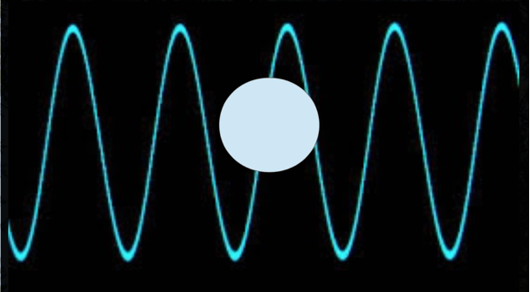
Fig. 7. Atomic interaction with gamma-rays
If the gamma ray frequency is slightly off the resonant frequency of the size of the atom, the dissociation will produce showers of subatomic particles, and a force, as a result.
Source: Boyd, R. N. (2019). Continuous creation/dis-creation of matter and energy in an infinite volume, constantly equilibrating universe
In experimental range, a gamma-ray laser may reproduce this effect by interacting with any atomic element in a time determined by the interaction rate, which is a function of surface area of the material and the gamma-ray laser intensity, in the case that the gamma-rays are coherent and have the same frequency. At the actual technology level, gamma-ray filters may be used for this purpose. Should the gamma-ray frequency be slightly off the resonant frequency of the size of the atom, the dissociation will produce showers of subatomic particles and a force, as a result. The kind of this force is determined by the difference in size between the gamma ray and the size of the given atom. Thus heat, cold, repulsive force, electricity, gravitation, magnetism, propulsive force on a vector, light and other EM radiations as well as changes in the quantum field can be selected and produced by changing the resonant frequency difference between the gamma-ray and the size of the atoms being used.
Further on, aether flows past an existing electron result in Von Karman vortex-shedding resonances, thus creating alternating electrons and positrons rotating in alternating directions. Electron/positron pairs distributed in the same line can become protons, neutrons and atom, according to the number of pairs produced in the aether-flow, which are participating in the process (Fig. 8).
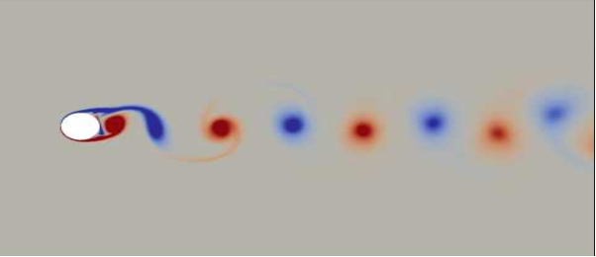
Fig. 8. Electron-related Aether flows
Aether flows past an existing electron results in Von Karman Vortex-shedding resonances. Creates alternating electrons and positrons rotating in alternating directions. e-p pairs in the same line, can become protons, neutrons, and atoms, depending how many pairs are produced in the aether flow, to participate.
Source: Boyd, R. N. (2019). Continuous creation/dis-creation of matter and energy in an infinite volume, constantly equilibrating universe
Interestingly enough, the aether flows are comprised of vortex lines propagating at infinite velocity as long as they travel in a straight line. When vortex lines are bent, electric charge arises. Particle charges are similarly dependent on the circulation variant of these vortex lines. As proved by the „Safire Project”, charge separation layers in plasmas create new atoms (Fig. 9)
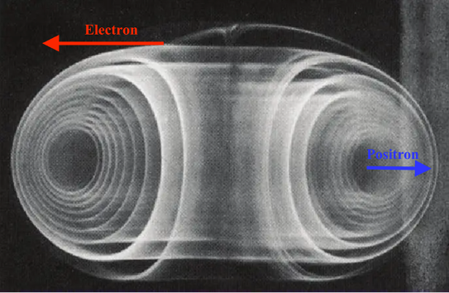
Fig. 9. Charge arises from aether vortex lines
These aether flows are comprised of „vortex lines” which propagate at an infinite velocity as long as they travel in a straight line. When vortex lines are bent, electric charge arises. Circulations of vortex lines make particle changes + and –
Source: Boyd, R. N. (2019). Continuous creation/dis-creation of matter and energy in an infinite volume, constantly equilibrating universe
At a planetary level, telluric aether current rivers are immensely powerful creation channels, similar to dark mode plasma flows, as they pass at every depth, representing channels where new atoms are created (Fig. 10). Self-collimating and self-focusing aether flows also form ruler-straight thin black threads which connect objects, and transport experiential information both ways between a couple of end-points, superluminally.
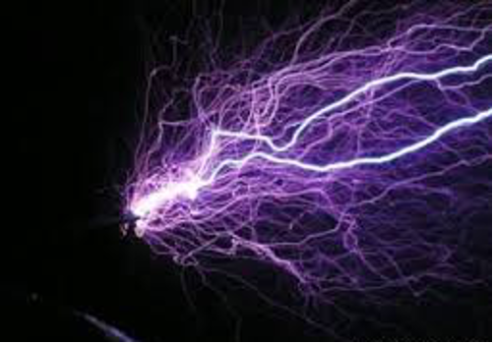
Fig. 10. Telluric aether currents
Telluric Aether-Current Rivers are immensely powerful Creation Channels, similar to dark mode plasma flows.
Source: Boyd, R. N. (2019). Continuous creation/dis-creation of matter and energy in an infinite volume, constantly equilibrating universe
At the universal scale, our sentient Universe is exceedingly anisotropic (vaguely isotropic in the infinite velocity portion of the Mishin 5th phase aether). When the infinite velocity vortex lines get slowed down and diverted by various interactions, turbulence develops (along with time). By Kolmogorov’s 5/3 law, the Kolmogorov limit is 10e-58m, and this is the critical point where the smallest turbulence-generated vortex can exist as a coherent entity, and the smallest one that can be influenced by gravity.
A subquantum microscope built many years ago by Dr, R. N. Boyd and currently located in Serbia, succeeded to image entities of the 10e – 95m order, thus far smaller than the Kolmogorov vortex. Such entities (smaller than 10e – 58m) are the primary cause of gravitation, which is determined by superluminal aether in-flows. It may be reasonably claimed that Gravitation’s opposite manifestation variants are the EM radiation and vortex lines, which act to originate new matter in many different ways.
CONCLUSIVE REMARK
Modern physical and cosmological theories will be fundamentally flowed if the earlier concept of the Aether as the universal propagation medium for waves of all kinds and the sub-quantum Information carrier systems, would not be reassessed and repositioned at their very fundaments.
Late advanced research programs in these fields of scientific inquiry strongly support this tenet.
Open-minded scholars who resonate with this view are kindly invited to contribute to its further refining in the “Academic debates” section of our Forum.
REFERENCES & BIBLIOGRAPHY
Boyd, R. N. (2019). Continuous creation/dis-creation of matter and energy in an infinite volume, constantly equilibrating universe, Lecture at “Physics Beyond Relativity” Prague.
Boyd, R. N. (n.d.). Subquantum physics and ether theories https://www.rialian.com/rnboyd/subquantum.htm
Christianto, V., Smarandache F. & R. N.Boyd. (2018). Helmholtz electron vortex from Kolmogorov’s theory of turbulence and a new model of origination of charge and matter, https://www.researchgate.net/publication/329072312_Helmholtz_electron_vortex_from_Kolmogorov’s_theory_of_turbulence_and_a_new_model_of_origination_of_charge_and_matter
Christianto, V., Smarandache F., Boyd R. N. & Chandra, D. (2019 ). Remark on Unified VorticalSingularity (UVS) model in Comparison with Navier-Stokes Cosmology, in New Foundation in the Sciences, Penerbit Eunoia Media.
Marjanovic, G. (2014a). Akasha-forerunner of Ether – “Superfluid quantum vacuum”, http://users.beotel.net/~gmarjanovic/SpecFluid_e.pdf
Marjanovic, G. (2014b). Pyramids – an interface for communication with the supernatural Reality, http://www.teslascalar.com/Engl/Piramide_e.pdf
Marjanovic, G. (2018). Pyramids and Scalar Waves, Lecture at 1st Global Pyramid Energy Conference, May 7-13, 2018, Visoko, BIH.
Klein, A. & Boyd, R. N. (2008). Information and the ether, the subtle energies, http://www.victorzammit.com/articles/Klein9.htm

